**Lab 7 Activity 3 - Sorting and Filtering Data**

**Objective:** Use Excel’s sorting and filtering options to manage data efficiently.

1. Click on any column header in the table.

2. Use the "Sort & Filter" option to sort alphabetically or by numerical value.

3. Apply filters to display only specific rows based on conditions.

4. Clear the filter and save the workbook.

**__________________________________________________________________________________**

**Solutions:**

**Task 1:**

* Open your Excel workbook containing the student data table.
* Click on any column header, such as "Name" or "Marks".

**Task 2:**

1. Go to the Home tab or Data tab.
2. Choose Click on Sort & Filter.
3. a sorting option:
4. Alphabetically (A → Z or Z → A) for text-based columns (e.g., "Name").
5. 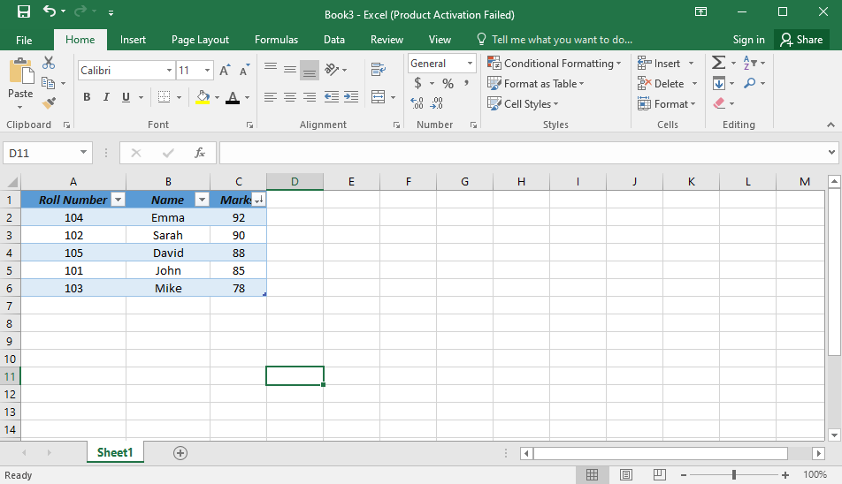Numerically (Smallest to Largest or Largest to Smallest) for number-based columns (e.g., "Marks").

**Task 3:**

1. Click on the dropdown arrow in any column header (appears after formatting as a table).
2. Uncheck "Select All" and choose specific values to filter.
3. Click OK to display only rows matching the selected condition.

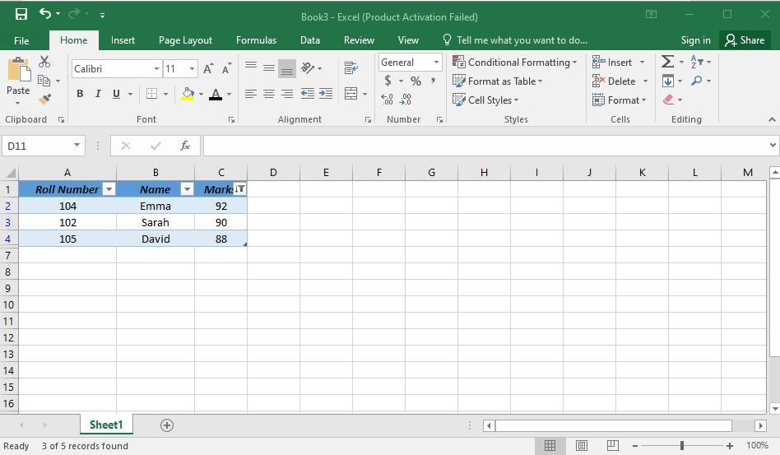

**Task 4:**

1. Click on Sort & Filter > Clear to remove filters.
2. Go to File > Save to update the workbook.
3. Close Excel.